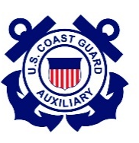
DEPARTMENT of HOMELAND SECURITY
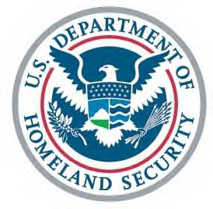

UNITED STATES COAST GUARD AUXILIARY

Flotilla 014-02-06

Monmouth Beach, NJ

Minutes for the March 18th, 2021 meeting.

Meeting called to order at 19:30.

Meeting was held remotely via Zoom.

Awards: There were no awards presented.

Catherine Dudley played an informative video on the historical development of the Auxiliary.

FC (Catherine Dudley) – Did not attend the Division Meeting. Has continued to forward various information and reports of interest to members of the Flotilla.

VFC (Tony Milillo) – Discussion at Division Meeting regarding payment of dues, updated Standing Rules developed, flexible goals related to the impact of Covid-19 crafted, and the budget passed. An electronic e-mail communication is going to be developed for dealer visits. Came to light that many paddlers do not have whistles, so arrangements are being made for their distribution. Talk of Sea Scouts program: looking for anyone with scouting experience who is interested in becoming involved as a potential Scoutmaster.

FSO-SR (Dennis Mikolay) – Minutes of February 2021 meeting approved.

FSO-FN (Vince Mancino) – Report submitted electronically. Three (3) disbursements and zero (0) cash receipts. All bills presented have been paid. There was a total of three (3) bills presented. Both the District and Division annual dues were paid. Finance Report approved.

FSO-OP (Dan Smuro) – Report submitted electronically. Nothing additional to add.

FSO-HR (Fred Klapproth) – Nothing to report. No current recruiting candidates.

FSO-IS (Dan Smuro) – Report submitted electronically. Nothing additional to add.

FSO-MA (Walt Kudler) – Report submitted electronically. Nothing additional to add.

FSO-MS (Lou Krupkin) – Report submitted electronically. Nothing additional to add.

FSO-NS (Bob McNamara) – Report submitted electronically. Nothing additional to add.

FSO-MT (Dan Smuro) – Report submitted electronically. Members are encouraged to reach out regarding what training mediums are preferable—see the report for more information on this matter. Nothing additional to add.

FSO-CS (Bill Szilasi) – N/A (Confirmed: Nothing to report).

FSO-PB (Amanda Prascsak) – Nothing to report.

FSO-PE (Fred Klapproth) – Report submitted electronically. Nothing additional to add.

FSO-PV (Tony Milillo) – Joe Antonaccio had a workshop—PV and PE—the main thrust of it was that those two programs are where “the rubber meets the road” and most interactions between the Auxiliary and boating public occur.

FSO-VE (Dave Radeschi) – Report submitted electronically. Noted that new law requires (as of April 1st, 2021) that boats less than twenty-six (26) feet must use an engine cut-off switch link. Patten Point Yacht Club event still planned.

FSO-CM (Joe Ruffini) – N/A

Aviation Advisor (Doug Livornese) – Report submitted electronically.

Uniform and Flag (Lee Ward) – New document regarding placement of devices on blouse sent via e-mail.

New Business: N/A

Good and Welfare: N/A

Committee Reports: N/A

