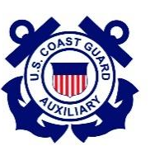
DEPARTMENT of HOMELAND SECURITY
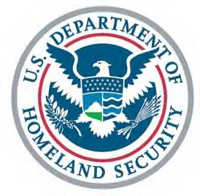

UNITED STATES COAST GUARD AUXILIARY

Flotilla 014-02-06

Monmouth Beach, NJ

Minutes for the 21 April 2022 Meeting

Meeting called to order at 19:35.

Guests: Frank Salerno and Bill Neeto

Awards: No Awards.

FC report (Catherine Dudley) - Given by Tony Milillo in absentia. Discussed Memorial Day observance. 2-6 to observe. Lee Ward suggested the need for flag raisers - ideally 4 people.

VFC (Tony Milillo) – Nothing specific to report

FSO-SR (Fred Klapproth) - Nothing to specific report

FSO-SR (Catherine Dudley) - Given by Tony Milillo in absentia. No old minutes.

FSO-FN(Vince Mancino) – Submitted report electronically. A number of disbursements listed in his report. For the year (as of March 31) we are negative $332. However, for April expected to be back in the black. Proposed that any expenditure must be approved by motion. There was a motion to give a monthly allowance to the cultural center. Dave Radeschi made the motion to donate and Fred seconded.

The motion will donate $25/month to be given quarterly for every month of the fiscal year. Motion was carried

Tony Milillo - discussed and presented to members that time for flotilla meetings to be put in AUXDATA II by FC or VFC. Shared that only time for travel and prep should be recorded by members.

FSO-OP (Dave Radeschi) – No patrols scheduled. Planning on getting a larger vessel (45 ft) for a patrol. This should be available for Fleet Week.

FSO-HR (Fred Klapproth) – submitted electronically. Frank Salerno and Bill Neeto are joining the flotilla.

FSO-MA (Walt Kudler) –submitted electronically

FSO-PB (Amanda Prascsak) – not present

FSO-MT (Fred Klapproth) – Looking to get members certified for vessel examinations. Started boat crew training on Tuesday the 19th. Physical requirements, Fatigue and First Aid - presentation given by Doug Livernese. Additional workshops required and should be completed by end of June.

Tony Milillo - Gave a description of duties of program visitors

FSO-PV (Tony Milillo)- submitted electronically

FSO-VE (Dave Radeschi) – Vessel examinations scheduled for Saturday May 21st at Patten Point Yacht Club and another scheduled for the Saturday after memorial day in Marine Red Bank (June 4th). He is expecting to schedule a few more. Also has collected decals for this year - Orange color. Dave passed out vessel examiner safety check forms. It was estimated that each safety check will be ~30 min per boat

Aviation Advisor – submitted electronically. Nothing new from aviation.

Uniform and Flag – reviewed saluting protocol.

Old Business: No old business

New Business: No new business

Good and Welfare

Motion to Adjourn @ 10:15

